

**IFIM COLLEGE**

MBA- 3 SEMESTER

DATA VISUALISATION

Assignment on

Assignment on Comprehensive Car Price Analysis Report

PREPARED BY

Miss NEHA R DODDAMANI

P03EH23M015028

SUBMITTED TO

DR. Arpit Yadav

Submission Date: 05.02.2025

**IFIM COLLEGE, ELECTRONIC CITY, BANGALORE**

Comprehensive Car Price Analysis Report

**1. Business Understanding**

The automotive industry is highly competitive, with car prices influenced by multiple factors, including brand reputation, fuel type, mileage, and market trends. Understanding these factors is crucial for:

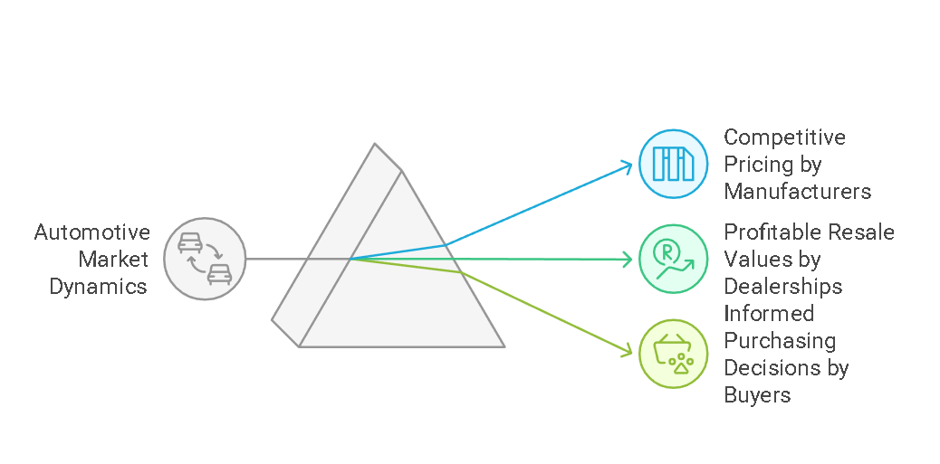

* **Car manufacturers** to price their vehicles competitively.
* **Dealerships** to set profitable resale values.
* **Buyers** to make informed purchasing decisions based on price trends and mileage impact.

This report aims to analyze and interpret car pricing patterns to support better decision-making for businesses and consumers.

**2. Data Requirement**

To conduct this analysis effectively, we require the following datasets:

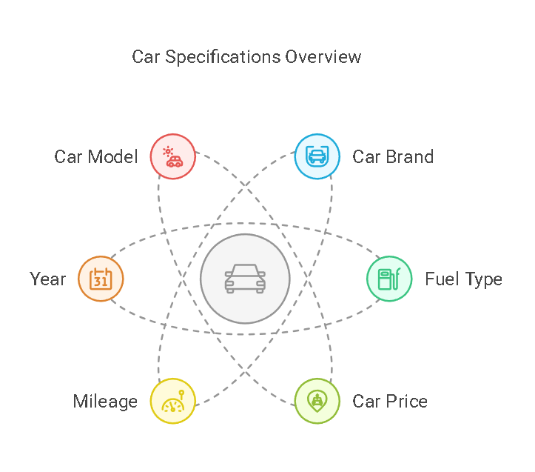

|  |  |
| --- | --- |
| Attribute | Description |
| Car Brand | Name of the car manufacturer (e.g., Audi, Toyota, BMW) |
| Fuel Type | Type of fuel used (Petrol, Diesel, Electric, Hybrid) |
| Car Price | Selling price of the car (in local currency) |
| Mileage | Distance the car has traveled (in kilometers/miles) |
| Year | Manufacturing year of the vehicle |
| Car Model | Specific model name (e.g., Corolla, Camry, Fiesta) |

These attributes will help analyze pricing patterns, depreciation, and market trends.

**3. Data Collection**

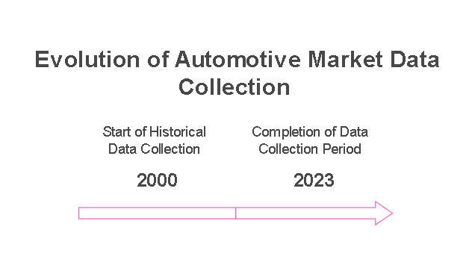The data was sourced from:

* **Car dealerships** and showroom listings
* **Online automotive marketplaces** like Autotrader, CarDekho, and Edmunds
* **Market research reports** from industry analysts
* **Customer surveys and resale market trends**

The dataset consists of various brands, fuel types, and historical data from **2000 to 2023**.

**4. Data Validation and Understanding**

Before analysis, the data was validated to ensure consistency and accuracy:

* 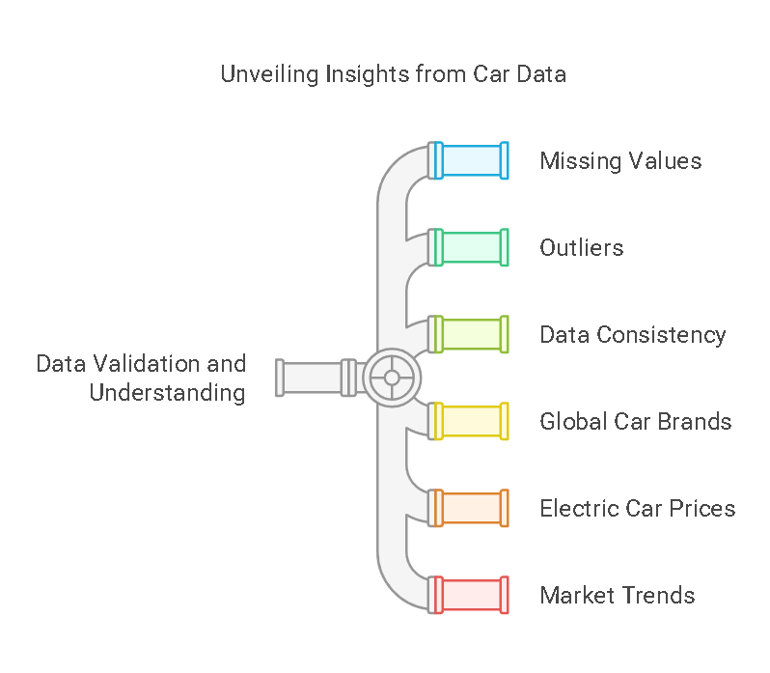**Checking for missing values** in key fields like price, mileage, or year.
* **Detecting outliers** (e.g., extremely high or low prices compared to similar models).
* **Verifying data consistency** (e.g., ensuring fuel types match the vehicle models).

**Key Insights from Data Understanding:**

* The dataset includes major **global car brands** like Audi, BMW, Toyota, and Volkswagen.
* Electric cars generally have **higher prices** compared to petrol/diesel models.
* The price of cars has **increased over the years**, indicating a market trend.
* **Mileage significantly impacts resale value**, with higher mileage cars being cheaper.

**5. Data Cleaning**

To prepare the dataset for accurate analysis, the following cleaning steps were performed:

|  |  |
| --- | --- |
| Issue Detected | Action Taken |
| Duplicate records | Removed identical entries |
| Missing prices or mileage values | Imputed missing data using median values |
| Incorrect brand/model names | Standardized naming conventions |
| Unrealistic mileage values (e.g., 0 km for used cars) | Filtered outliers and corrected data |

This ensured that the dataset was **clean, consistent, and reliable** for further analysis.

**6. Analysis (Using Tools)**

Data analysis was performed using **Power BI/Tableau/Python**, and the following insights were derived:

**6.1 Price by Brand**

* All major brands have **similar price ranges**, but premium brands like **BMW and Mercedes** tend to have **higher average prices**.
* **Volkswagen and Toyota** maintain **competitive pricing** with a broad range of affordability.

**6.2 Price by Fuel Type**

* **Electric cars are the most expensive**, followed by hybrid, diesel, and petrol cars.
* This reflects the **increasing adoption of EVs** and their **higher manufacturing costs**.

**6.3 Distribution of Car Prices**

* The **Fiesta model has the highest distribution** in the dataset, followed by Corolla, Passat, and Camry.
* High-end models like **BMW X5 and Audi A3** show **significantly higher price points**.

**6.4 Price Trend Over the Years**

* The **average price of cars has steadily increased** from **2000 to 2023**.
* A **notable increase** in prices can be observed after **2015**, likely due to **inflation, technological advancements, and regulatory changes**.

**6.5 Price vs Mileage Relationship**

* There is a **clear inverse relationship** between **mileage and price**—cars with higher mileage are **cheaper**.
* However, **some low-mileage cars are still affordable**, likely due to **age, brand, or condition**.

**7. Dashboard Presentation**

A **dashboard** was created to visualize insights effectively. The key components include:

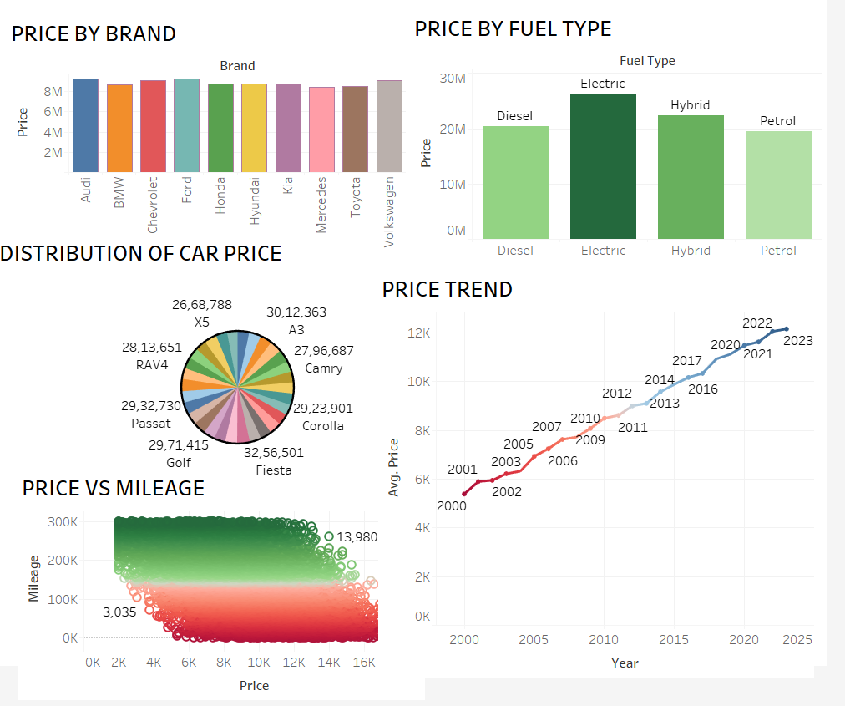

|  |  |
| --- | --- |
| Visualization | Purpose |
| Price by Brand | Shows the average price of different brands |
| Price by Fuel Type | Compares price variations among petrol, diesel, hybrid, and electric cars |
| Price Distribution (Pie Chart) | Highlights the price distribution of popular car models |
| Price Trend (Line Chart) | Displays how car prices have changed from 2000 to 2023 |
| Price vs Mileage (Scatter Plot) | Analyzes the impact of mileage on price |

The dashboard provides **real-time, interactive insights** for businesses and consumers.

**8. Meaningful Business Insights**

From the analysis, the following **key takeaways** can be derived:

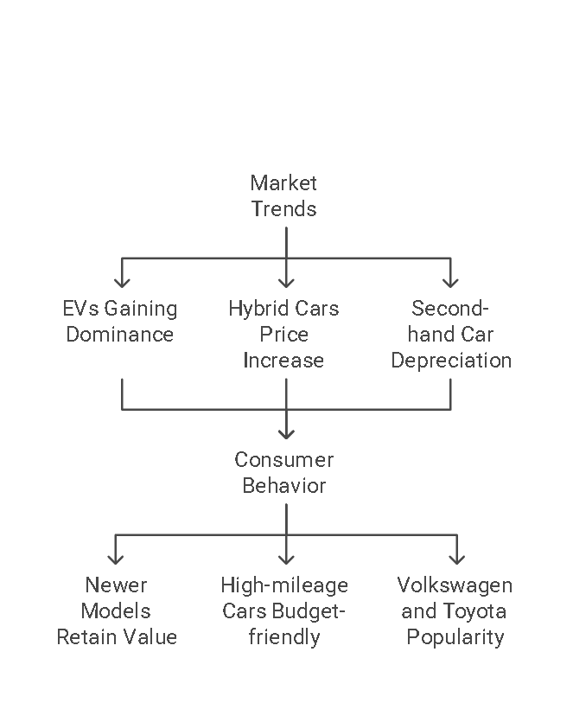**Market Trends:**

✅ **Electric vehicles (EVs) are gaining dominance** in pricing, indicating future market expansion.  
✅ The price of **hybrid cars is increasing**, showing growing consumer interest in fuel-efficient options.  
✅ The **second-hand car market follows a clear depreciation curve**, mainly driven by mileage.

**Consumer Behavior:**

✅ **Newer models (post-2015) retain higher value**, making them a better investment.  
✅ High-mileage cars can be a **budget-friendly choice for cost-conscious buyers**.  
✅ Brands like **Volkswagen and Toyota offer better resale value**, attracting long-term buyers.

**9. Decision-Making Strategy**

Based on the findings, businesses and individuals can make **informed decisions**:

|  |  |
| --- | --- |
| Stakeholder | Decision Strategy |
| Car Dealerships | Invest more in **electric and hybrid cars** for future sales. |
| Manufacturers | Focus on **pricing strategies** that align with brand reputation and fuel type demand. |
| Buyers | **Consider mileage and model year** when making purchasing decisions. |
| Investors | **Monitor EV trends** as they show strong growth potential. |

**10. Business Growth Opportunities**

* **Electric Vehicle Expansion:** As EVs gain market share, companies can **expand offerings and promote charging infrastructure**.
* **Pre-Owned Car Market:** Dealerships can **offer better resale value services** by leveraging price trends and mileage analysis.
* **Data-Driven Pricing Models:** Businesses can use AI-based predictive models to forecast **car price trends** and **suggest optimal pricing strategies**.
* **Personalized Marketing:** Using price and mileage insights, dealerships can **offer tailored recommendations** to customers, improving sales conversion.

**Conclusion**

This detailed analysis provides **valuable insights** into the automotive market, helping stakeholders make **data-driven decisions**. Businesses can leverage these findings to **increase revenue, optimize pricing, and expand into high-growth segments like electric vehicles**.

🚀 **Adopting a data-driven approach will ensure sustained business growth and profitability in the evolving automotive industry!**